1. 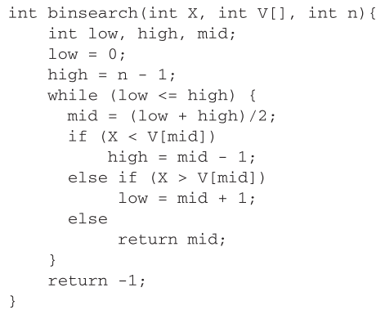**[10]**

1. Draw dataflow graph of above code. You may use the backside of this quiz

**Answer on back page**

1. Find out the cyclomatic complexity of the code from your flow chart. Use both methods discussed in class.
2. [2 marks each] Short Q/As
3. Which of the following term describes testing?  
   a) Finding broken code **b) Evaluating deliverable to find errors** c) A stage of all projects  
   d) None of the mentioned
4. Boundary value analysis belongs to? **Black-box testing**
5. Boundary value analysis and Equivalence Class testing are usually performed separately. True / **False**
6. Which of the following is not a software testing generic characteristics?  
   a) **Different testing techniques are appropriate at different points in time**  
   b) Testing is conducted by the developer of the software or an independent test group  
   c) Testing and debugging are different activities, but debugging must be accommodated in any testing strategy  
   d) None of the mentioned
7. In a system designed to work out the tax to be paid: An employee has $4000 of salary tax free. The next $1500 is taxed at 10% The next $28000 is taxed at 22% Any further amount is taxed at 40%. Which of these groups of numbers would fall into the same equivalence class?
8. **$5800; $28000; $32000** c) $0; $200; $4200
9. $5200; $5500; $28000 d) $28001; $32000; $35000

Question 1 part a answer. Other answers also possible.

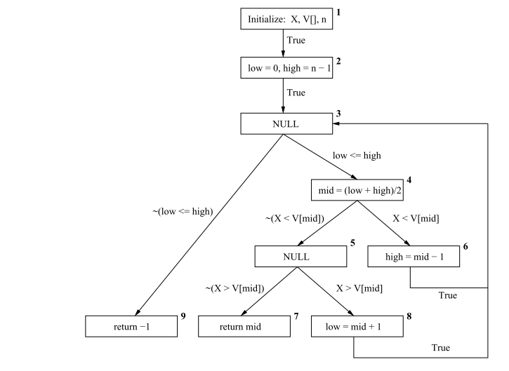

An economics application estimates the human poverty index (HPI) of a country by considering its GDP in billions of US dollars (0.0 – 100.0, 100.0+), its unemployment rate (UR) as a percentage (0.0 – 10.0, 10.1 – 50.0, 50.1 – 100.0), its inflation rate (IR) (low, high), and its average family size (AFS) (very small, small, medium, large, very large). The HPI estimation module of this application uses the estimates shown in the table below.

|  |  |  |  |  |  |  |  |  |  |  |  |  |  |
| --- | --- | --- | --- | --- | --- | --- | --- | --- | --- | --- | --- | --- | --- |
| **GDP** |  | *0.0 – 100.0* | | | | | | *100.0+* | | | | | |
| **UR** |  | *0.0 – 10.0* | | *10.1 – 50.0* | | *50.1 – 100.0* | | *0.0 – 10.0* | | *10.1 – 50.0* | | *50.1 – 100.0* | |
| **IR** |  | *low* | *high* | *low* | *high* | *low* | *high* | *low* | *high* | *low* | *high* | *low* | *high* |
| **AFS** | *very small* | 14.5 | 13.5 | 15.5 | 15.0 | 14.0 | 16.0 | 10.0 | 11.0 | 11.5 | 12.5 | 12 | 13 |
| *small* | 15.5 | 14.5 | 16.5 | 16.0 | 15.0 | 17.0 | 11.0 | 12.0 | 12.5 | 13.5 | 13 | 14 |
| *medium* | 16.5 | 15.5 | 17.5 | 17.0 | 16.0 | 18.0 | 12.0 | 13.0 | 13.5 | 14.5 | 14 | 15 |
| *large* | 17.5 | 16.5 | 18.5 | 18.0 | 17.0 | 19.0 | 13.0 | 14.0 | 14.5 | 15.5 | 15 | 16 |
| *very large* | 18.5 | 17.5 | 19.5 | 19.0 | 18.0 | 20.0 | 14.0 | 15.0 | 15.5 | 16.5 | 16 | 17 |

Use ECP and BVA to fill out the following two tables for black-box testing of the HPI estimation module. Use **minimum** test cases in the last table.

|  |  |  |  |  |  |
| --- | --- | --- | --- | --- | --- |
| **Variable** | **Valid ECs** | **Representing values** | | **Invalid ECs** | **Representing values for invalid ECs** |
| **For valid ECs** | **Boundary values** |
| **GDP** | (1) 0.0 – 100.0  (2) 100.0+ | 50.0  150.0 | 0.0, 100.0  100.1 | (1) Any alpha-numeric value (not GDP) | ABC |
| **UR** | (1) 0.0 – 10.0  (2) 10.1 – 50.0  (3) 50.1 – 100.0 | 5.0  30.0  70.0 | 0.0, 10.0  10.1, 50.0  50.1, 100.0 | (1) Values > 100.0  (2) Any alpha-numeric value (not UR) | 150.0  DEF |
| **IR** | (1) low  (2) high | low  high |  | (1) Values other than low or high | medium |
| **AFS** | (1) very small  (2) small  (3) medium  (4) large  (5) very large | very small  small  medium  large  very large |  | (1) Values other than very small, small, medium, large, or very large | extra large |

Name: _______________________________ Roll Number: ______________ Section _____

|  |  |  |  |  |  |  |
| --- | --- | --- | --- | --- | --- | --- |
| **Test case type** | **Test case no.** | **GDP** | **UR** | **IR** | **AFS** | **Test case results (HPI)** |
| *For valid ECs* | 1 | 50.0 | 5.0 | low | very small | 14.5 |
| 2 | 150.0 | 30.0 | high | small | 13.5 |
| 3 | 50.0 | 70.0 | low | medium | 16.0 |
| 4 | 50.0 | 5.0 | low | large | 17.5 |
| 5 | 50.0 | 5.0 | low | very large | 18.5 |
| 6 | 0.0 | 0.0 | low | very small | 14.5 |
| 7 | 100.0 | 10.0 | low | very small | 14.5 |
| 8 | 100.1 | 10.1 | low | very small | 11.5 |
| 9 | 0.0 | 50.0 | low | very small | 15.5 |
| 10 | 0.0 | 50.1 | low | very small | 14.0 |
| 11 | 0.0 | 100.0 | low | very small | 14.0 |
|  |  |  |  |  |  |
|  |  |  |  |  |  |
|  |  |  |  |  |  |
|  |  |  |  |  |  |
|  |  |  |  |  |  |
| *For invalid ECs* | 12 | ABC | 5.0 | low | very small | Invalid GDP |
| 13 | 50.0 | 150.0 | low | very small | Invalid UR |
| 14 | 50.0 | DEF | low | very small | Invalid UR |
| 15 | 50.0 | 5.0 | medium | very small | Invalid IR |
| 16 | 50.0 | 5.0 | low | extra large | Invalid AFS |
|  |  |  |  |  |  |
|  |  |  |  |  |  |
|  |  |  |  |  |  |
|  |  |  |  |  |  |
|  |  |  |  |  |  |
|  |  |  |  |  |  |